|  |  |
| --- | --- |
| Subject: Machine Learning Lab | Course ID: CSL-604 |
| Semester: VI | Course: AI & DS |
| Laboratory: 406-B | Name of teacher: Prof. Seema Pawar |
| Name of Student: Ayush Gupta | Roll No: VU2S2324001 |

**EXPERIMENT NO. 5**

**Aim:**

To implement a Support Vector Machine (SVM).

**Theory:**

Support Vector Machines (SVMs) are supervised learning models used for classification and regression tasks. SVMs work by finding the optimal hyperplane that best separates data points into different categories. The goal is to maximize the margin, the distance between the closest data points (support vectors) and the decision boundary.

For linearly separable data, SVMs find a straight line (or hyperplane in higher dimensions) that best divides the classes. For non-linearly separable data, SVMs use kernel functions to transform the input data into a higher-dimensional space where a linear boundary can be applied.

One of the most popular implementations of SVM is the **Sequential Minimal Optimization (SMO) algorithm**, which breaks the large optimization problem into smaller subproblems that can be solved efficiently.

SVMs are widely used in applications such as **image recognition, text classification, bioinformatics, and handwriting recognition**, due to their ability to handle high-dimensional data and robust performance in complex classification tasks.

**Algorithm:**

The SVM algorithm follows an iterative approach to optimize the separation between different classes. It aims to maximize the margin between the support vectors and the decision boundary, ensuring better generalization to unseen data.

1. Initialize an alphas vector with zeros.
2. While the number of iterations is less than the maximum limit:
   * For each data vector in the dataset:
     + If the data vector can be optimized:
       - Select another data vector randomly.
       - Optimize the two vectors together.
       - If optimization is not possible, break the loop.

The optimization process ensures that the model converges to an optimal hyperplane, providing an effective classification of data points with minimal error.

**Flowchart:**

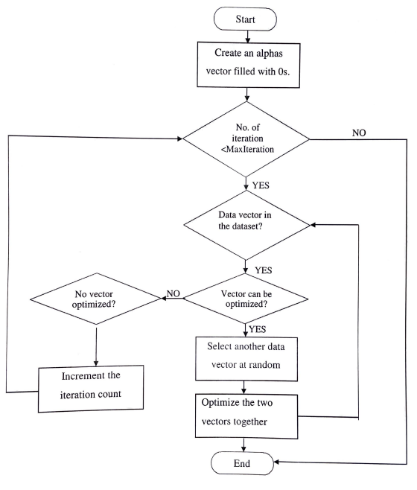

**Learning Outcomes:**

* Understanding the working principle of SVM.
* Implementing SVM for classification tasks.
* Learning how hyperplanes and kernel functions impact classification performance.
* Exploring different SVM kernel types (linear, polynomial, RBF) and their applications.

**Conclusion:**

Support Vector Machines are powerful tools for classification and regression problems. They provide optimal solutions for various data representations, including linear and non-linear separations using kernel functions. SVM is widely used due to its effectiveness in handling high-dimensional data and ensuring a robust decision boundary. Its ability to work well with small to medium-sized datasets while maintaining high accuracy makes it a preferred choice in machine learning applications.

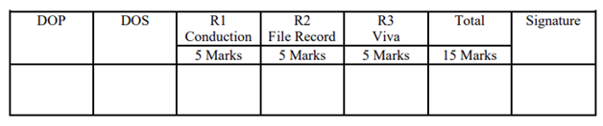

**Program:**

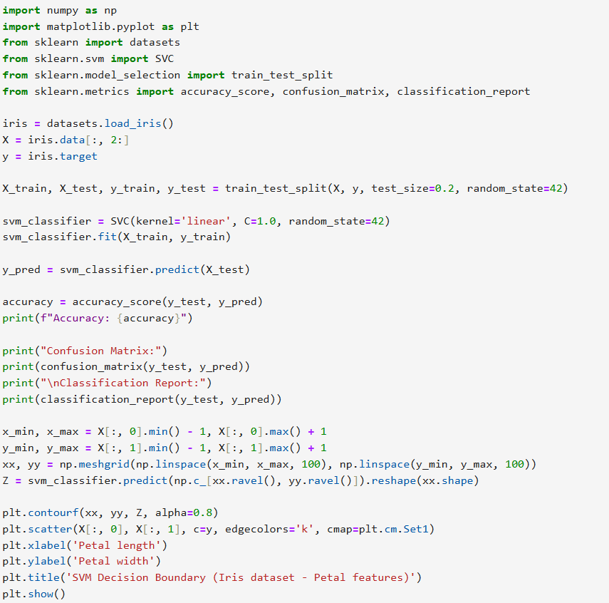

**Output:**

